Laptop Harbor



**GROUP MEMBERS**

**ROHAIL LAZARUS**

***Student1391529***

**BUSHRA**

***Student1412223***

**SAMIULLAH**

***Student1429988***

**SYED HUMAYOON AZIZ**

***Student1430859***

**AHMED MUJTABA SHAHZAD**

***Student1397463***

**EMAAN AMEEN**

***Student1440270***

CURRICULUM:

**7062**

BATCH:

**2211B1**

FACULTY:

**Sir Usama Riaz**

CO-ORDINATOR:

**MS MUNAZZAH**

MAIN PAGE:

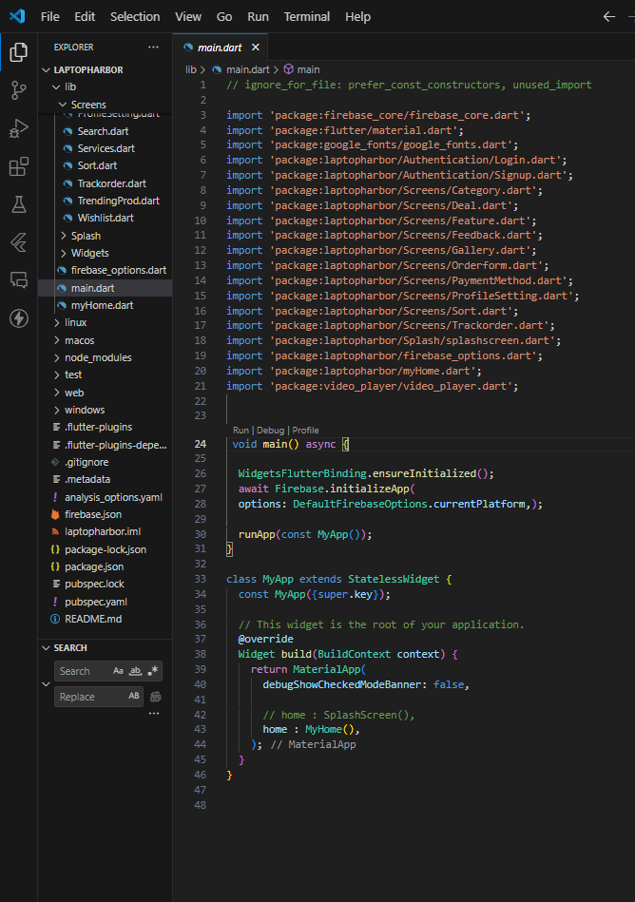

HOME PAGE CODE:

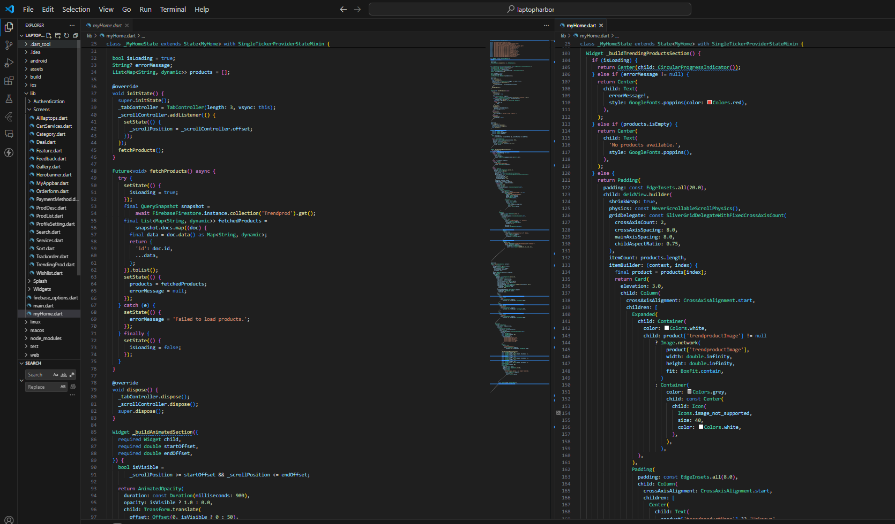

FEATURED PRODUCTS:

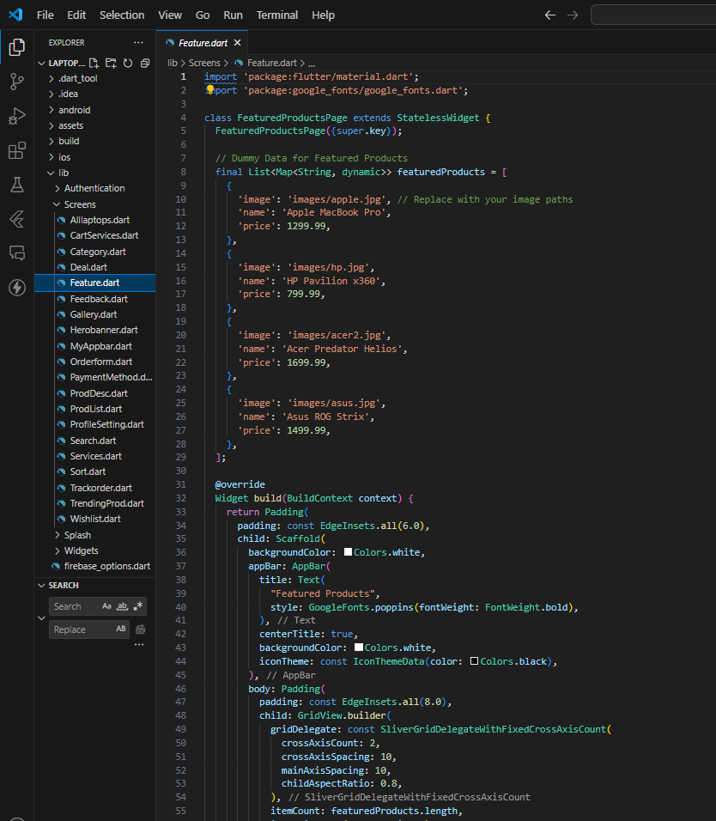

CATEGORY PAGE CODE:

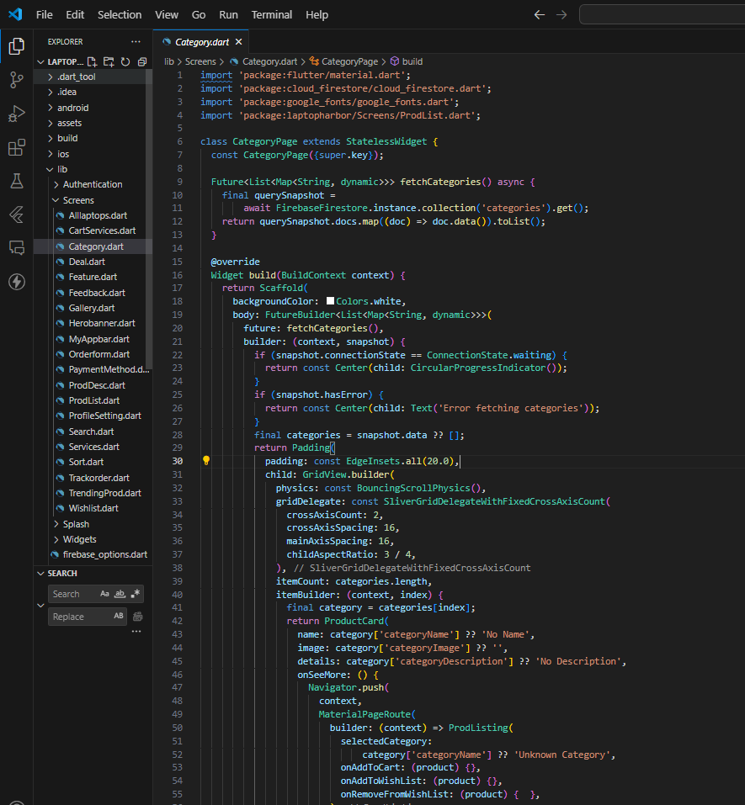

ADD, UPDATE & DELETE PRODUCT IN ADMIN PANEL:

ADDED USERS:

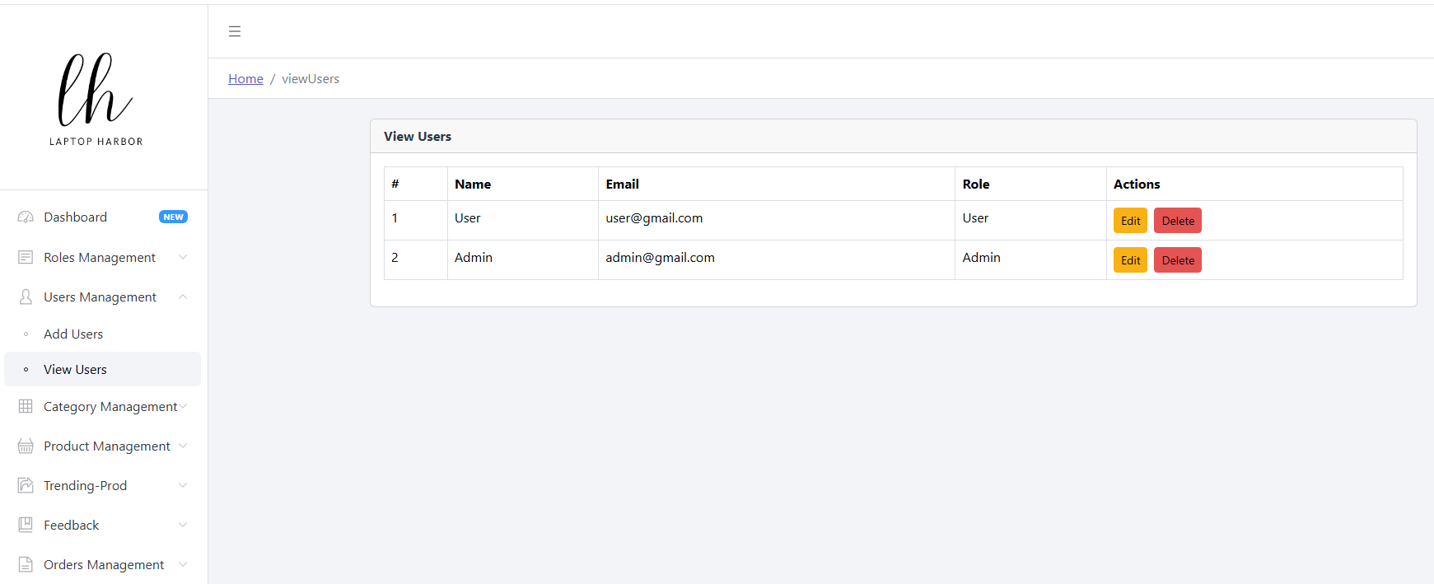

ADDED CATEGORIES:

